📘 Student Drop-off (Churn) Prediction – Model Training Documentation

1. Introduction
Student drop-off (churn) is a critical challenge in educational and training programs. Early prediction of student churn allows institutions to take preventive actions, improve retention, and enhance program effectiveness.
This project focuses on developing machine learning models to predict whether a student will drop off or successfully continue, using demographic, institutional, and behavioral features collected during the application process.

2. Objective
The objectives of this project are:
- To define student churn using real system statuses
- To prepare and engineer meaningful features from raw data
- To train multiple machine learning models for churn prediction
- To compare model performance using appropriate metrics
- To select the best-performing model for final deployment

3. Dataset Description
The cleaned dataset contains 8,327 student records with 14 initial features, including:
Categorical Features
- Opportunity Name
- Opportunity Category
- Gender
- Country
- Institution Name
- Current/Intended Major
- Continent
Numerical Features
- Age_at_Application_Int
- Institution_Participation_Count
- Signup month
- Signup weekday
Date Features
- Entry created at
- Apply Date
Target Variable
- churn (engineered)
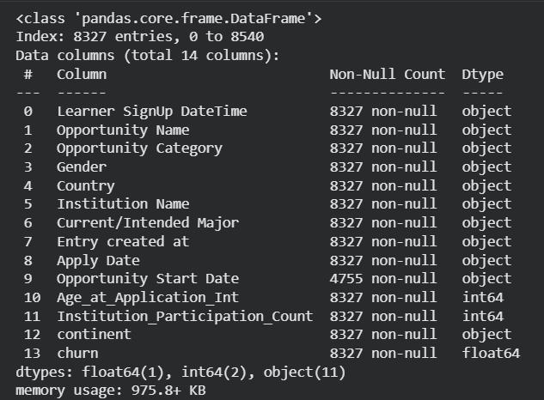Dataset overview (df.info() output)

4. Churn Definition (Target Engineering)
Student churn was defined using the Status Description column:
Status | Churn Label
dropped out, withdraw, rejected | 1 (Churn)
started, team allocated, rewards award | 0 (Non-churn)
applied, waitlisted | Removed (unknown outcome)
This approach ensures that the model learns only from confirmed outcomes.
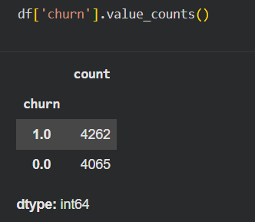
Code cell showing churn value counts

5. Data Preparation and Feature Engineering
5.1 Date Handling
Raw date columns were converted into meaningful behavioral features:
- Apply delay in days
- Application month
- Application weekday
After feature extraction, original date columns were removed.

5.2 Categorical Encoding
All categorical features were encoded using One-Hot Encoding, allowing models to process them numerically.
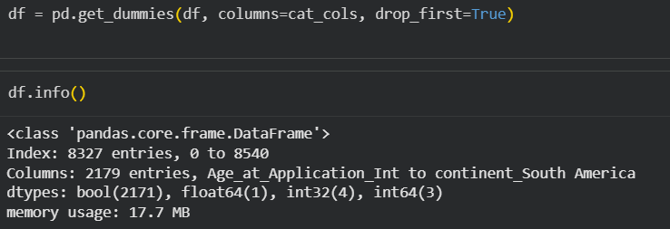pd.get_dummies() code cell

5.3 Feature Scaling
Numerical features were scaled using StandardScaler, which is required for models such as Logistic Regression.

5.4 Final Feature Set
After preprocessing, the dataset contained only numeric columns with no missing values, making it ready for model training.

6. Train-Test Split
The dataset was split into:
- 80% training data
- 20% testing data
Stratified sampling was used to maintain churn distribution.
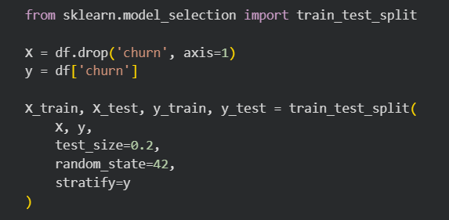
Train-test split code

7. Model Training
Three models were trained to compare performance:

7.1 Logistic Regression (Baseline Model)
- Used as a baseline
- Simple and interpretable
- Helps verify feature quality
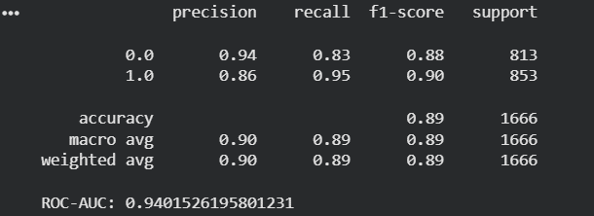
evaluation output result for Logistic regression training

7.2 Random Forest Classifier
- Handles non-linear relationships
- Robust to noise
- Provides feature importance
- Improved recall and ROC-AUC
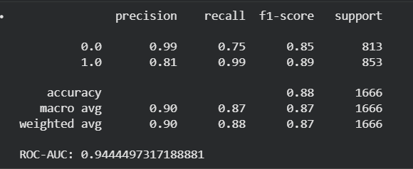
Random Forest results

7.3 Gradient Boosting Classifier
- Boosting-based ensemble model
- Best performance on churn data
- Captures complex interactions
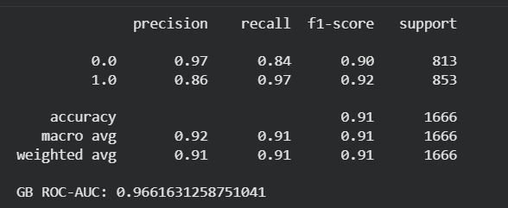
Gradient Boosting evaluation output

8. Model Evaluation
Models were evaluated using:
- Precision
- Recall (most important for churn)
- F1-score
- ROC-AUC
Performance Comparison
Model | ROC-AUC | Notes
Logistic Regression | Baseline | Interpretable
Random Forest | Higher | Better recall
Gradient Boosting | Highest | Final model

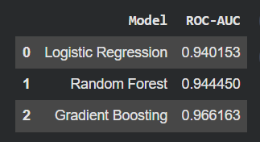

9. Feature Importance Analysis
Random Forest feature importance was analyzed to understand the main drivers of churn.
Top predictors included:
- Application delay
- Age at application
- Institution participation count
- Country / continent
- Opportunity category
This analysis helps institutions understand why students drop off, not just predict it.
📌 Screenshot to add here:
Feature importance plot or table

10. Final Model Selection
The Gradient Boosting Classifier was selected as the final model because it achieved:
- Highest ROC-AUC
- Better churn recall
- Stable performance across splits

11. Conclusion
This project successfully built and evaluated multiple machine learning models for student churn prediction.
Through careful feature engineering and model comparison, the final model demonstrated strong predictive performance and practical interpretability.
This system can be used to:
- Identify at-risk students early
- Improve retention strategies
- Support data-driven educational decisions

